**Web Sites**

This document contains samples of my work, highlighting the following:

**Web Site Design**

**Graphic Design**

**Requirements Gathering**

**James Coons**

**Email**: James.Coons@yahoo.com

**Phone**: 502-220-8569

Personal Website created using Weebly.com (v01)

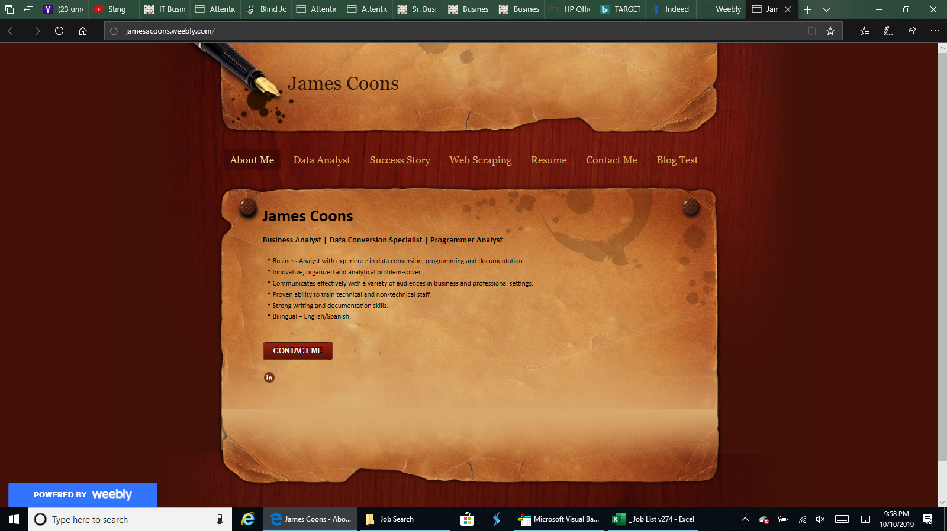

Personal Website created using Weebly.com (v02)

